Mirabal, Natasha

Brother Cheney

CIT230 Web Development

03/02/2018

**Website Planning**

**Name of Site**:

InfoWeather

**Site Purpose**:

Provide at persons a information on the city they are, to convey a daily forecast in terms of hight and low temperatures, amount of precipitation, and wind conditions for the areas of Franklinville, Greenville and Springfield.

Provide information and photos that is essential to planning ones day or vacations time using a extended forecast.

**Target Audience:**

Any people that is interested in the current and future weather conditions of the cities: Frankling, Springfield, and Greenville.

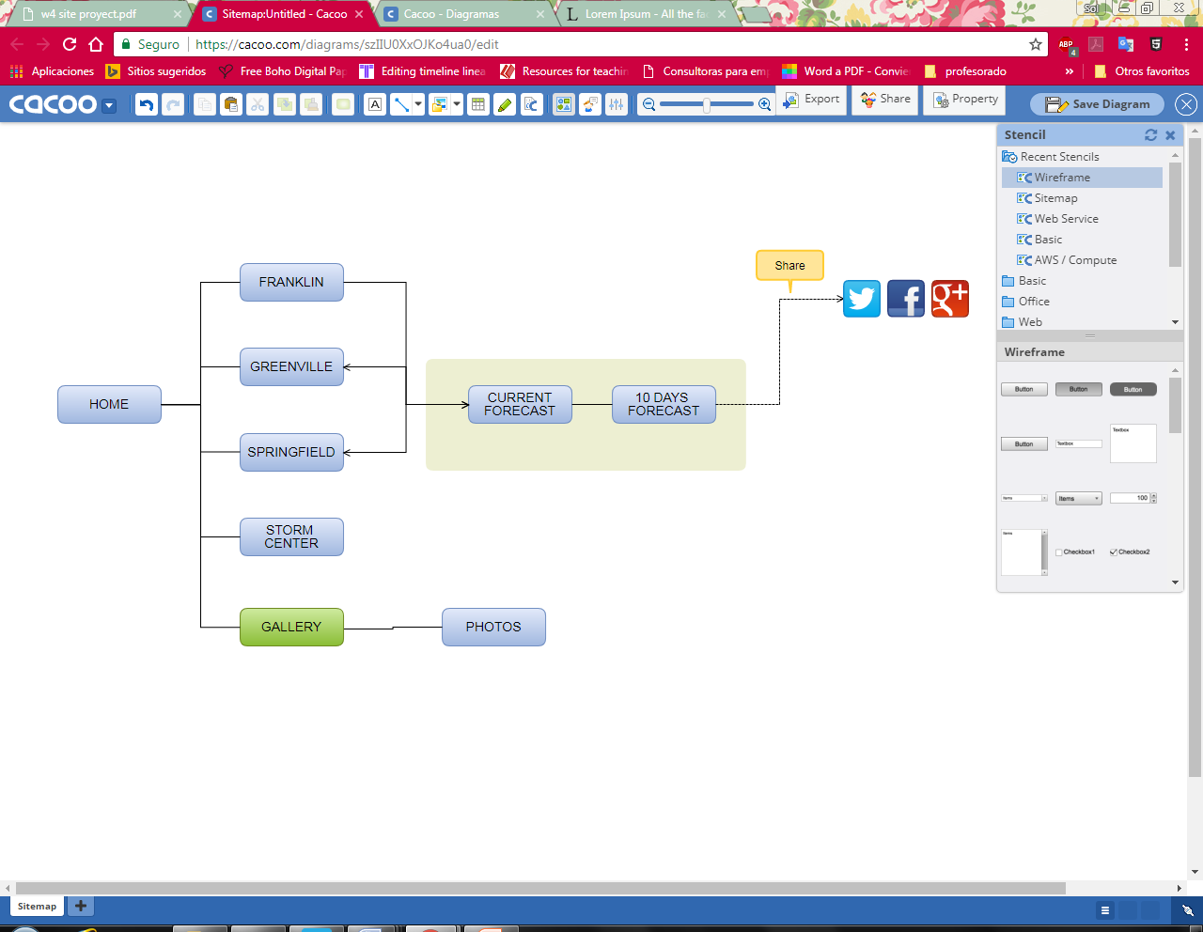**Site Map**:

Color Scheme : Monochromatic in Blue.

Primary # 44C3FF, Secondary # 369CCC, # 486E7F, # 91DBFF, # 22617F.

[*https://color.adobe.com/es/create/color-wheel/?base=2&rule=Monochromatic&selected=0&name=Mi%20tema%20de%20Color&mode=rgb&rgbvalues=0.13337862173518755,0.38201754033275837,0.5,0.5667572434703751,0.8605781084280895,1,0.2667572434703751,0.7640350806655167,1,0.2833786217351876,0.43028905421404473,0.5,0.2134057947763001,0.6112280645324134,0.8&swatchOrder=0,1,2,3,4*](https://color.adobe.com/es/create/color-wheel/?base=2&rule=Monochromatic&selected=0&name=Mi%20tema%20de%20Color&mode=rgb&rgbvalues=0.13337862173518755,0.38201754033275837,0.5,0.5667572434703751,0.8605781084280895,1,0.2667572434703751,0.7640350806655167,1,0.2833786217351876,0.43028905421404473,0.5,0.2134057947763001,0.6112280645324134,0.8&swatchOrder=0,1,2,3,4)

Typography – I will download some font according the theme of the web page, but probably it will be Open Sans.

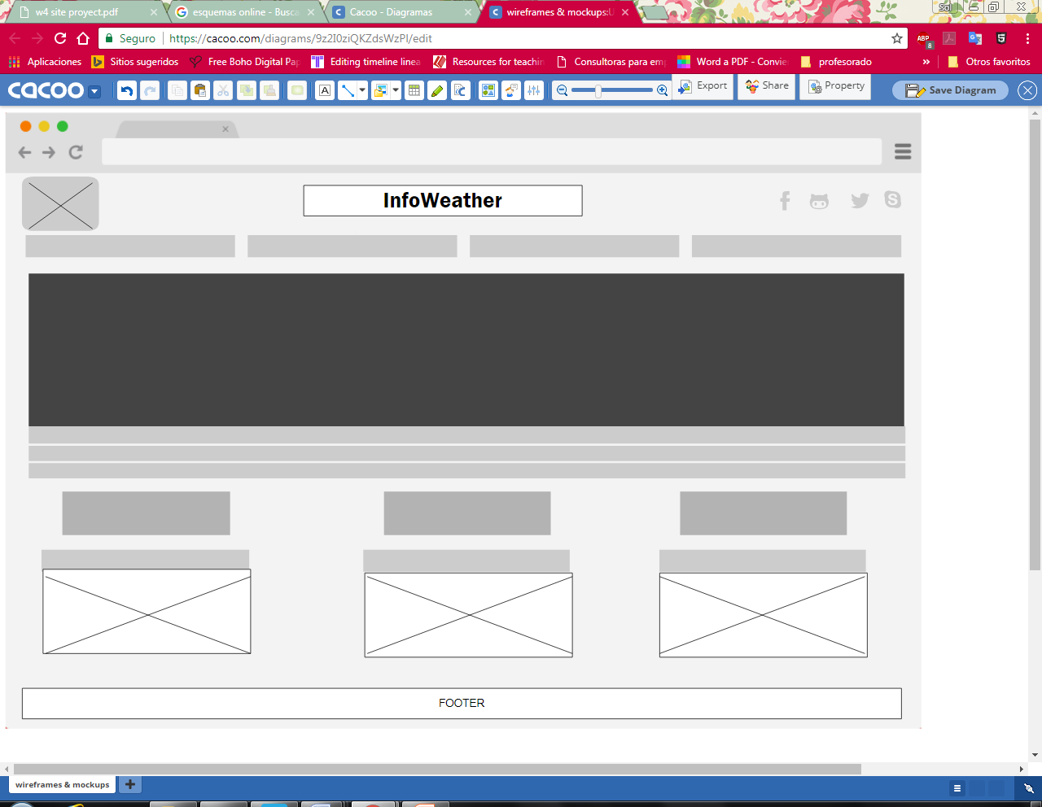Desktop:

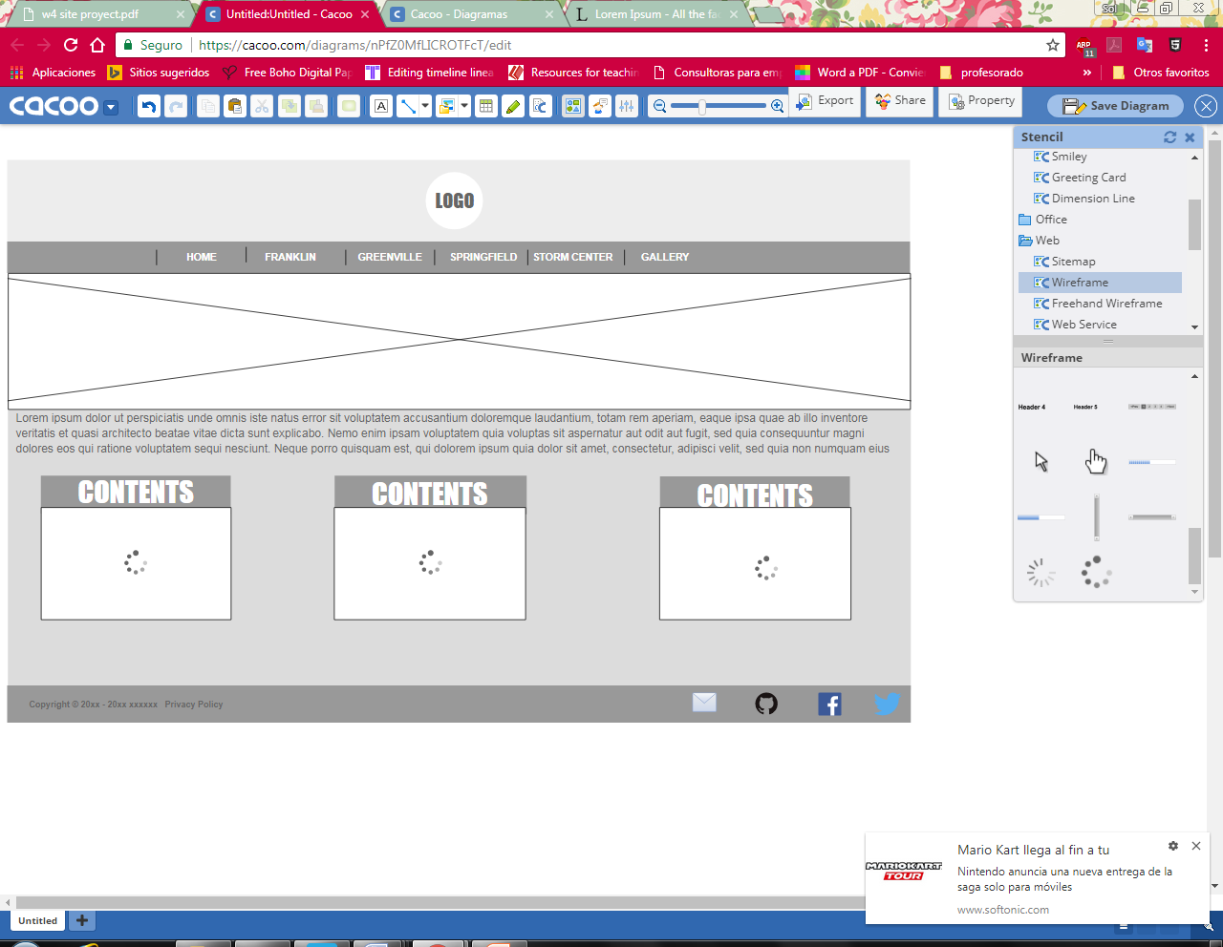Tablet:

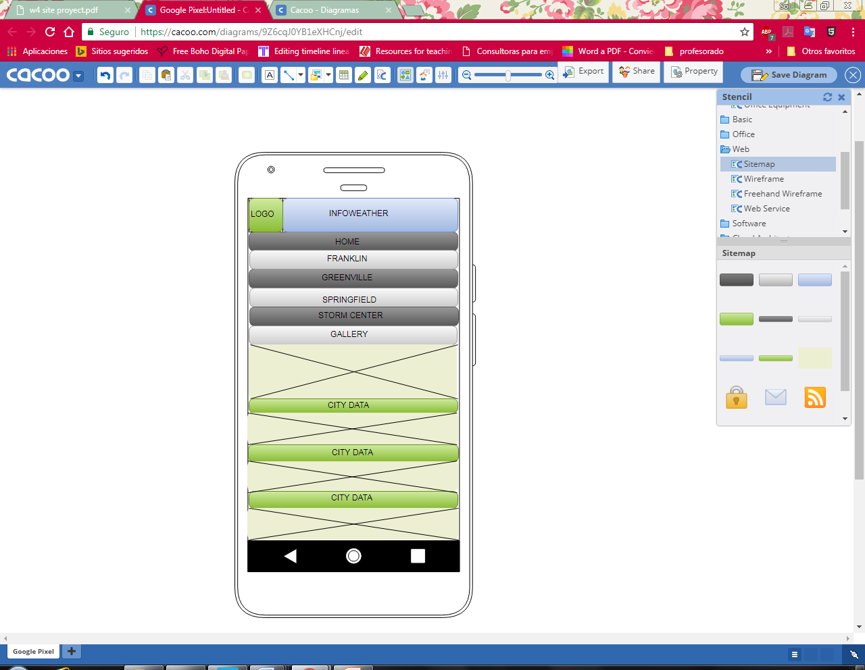Phones: